Axion All Access

​Team members:

Thomas Bonner, Reginald Uy, Ryan Niebla, Sufyan Fofana, Rong Cai

## Description

The Superhero App is a Single Page Application designed to allow a corporation that to maintain a fictional database of superheroes and villains. Heroes, teams, and employees of the corporation are allowed to access it and update information as the world evolves.

​

## Requirements

*Not Started - In Progress -* ***Complete***

1. [ ] Functionality should reflect the below user stories.

2. [ ] Data is stored in a database.

3. [ ] A custom stored procedure is called to perform some portion of the functionality.

4. [ ] Data Access is performed through the use of JDBC in a data layer consisting of Data

Access Objects.

5. [ ] All input is received using the java.util.Scanner class.

6. [ ] Log4j is implemented to log events to a file.

7. [ ] A minimum of one (1) JUnit test is written to test some functionality.​

8. [ ] Stack must implement:

* [ ] Platform:

[ ] AWS,

[ ] EC2

[ ] RDS,

[ ] Jenkins

[ ] Maven

* [ ] Front End:

[ ] HTML

[ ] CSS,

[ ] BootStrap

[ ] Angular

* [ ] Back End:

[~] Java - Implemented

[ ] **Spring**

* [ ] Database:

[ ] Oracle DB

[ ] Hibernate

​

## User Stories

|  |  |
| --- | --- |
| **Employee of Super Corporation**  [~] Approve / Reject promotion to team leader  [~] Register an employee  [~] View a log of all database activity  [~] Log in  [~] Log out |  |
| **Super Team Leader** [~] Approve Reject Team Transfer  [~] Add Team Members  [~] Remove Team Members |  |
| **User**  [~] Make a transfer request  [~] Create a team  [~] Request promotion to team leader  [~] Register a user  [~] Log in  [~] Log Out  [~] Search Superheroes / Supervillains  [~] Search Teams  [~] Get aggregates and statistics |  |
| ***Stretch goals***  *Super Team Leader*  [Unplanned] Add Team locations  [Unplanned] Modify Team Locations  *User*  [Unplanned] Modify hero/villain location  *Unsorted*  [Unplanned] Microtransactions  [Unplanned] For-purchase expandable Hero Limits  [Unplanned] Sweepstakes |  |

## UX Modules

User Login Page: Ryan

User Page: Reginald

User Page[Leader]: Tom / Reginald

Employee Login Page: Sufyan/Rong

Employee Page: Sufyan/Rong

## Object Layout

<https://www.lucidchart.com/invitations/accept/4873e424-4dfa-4d48-be4b-f8d7b6575730>

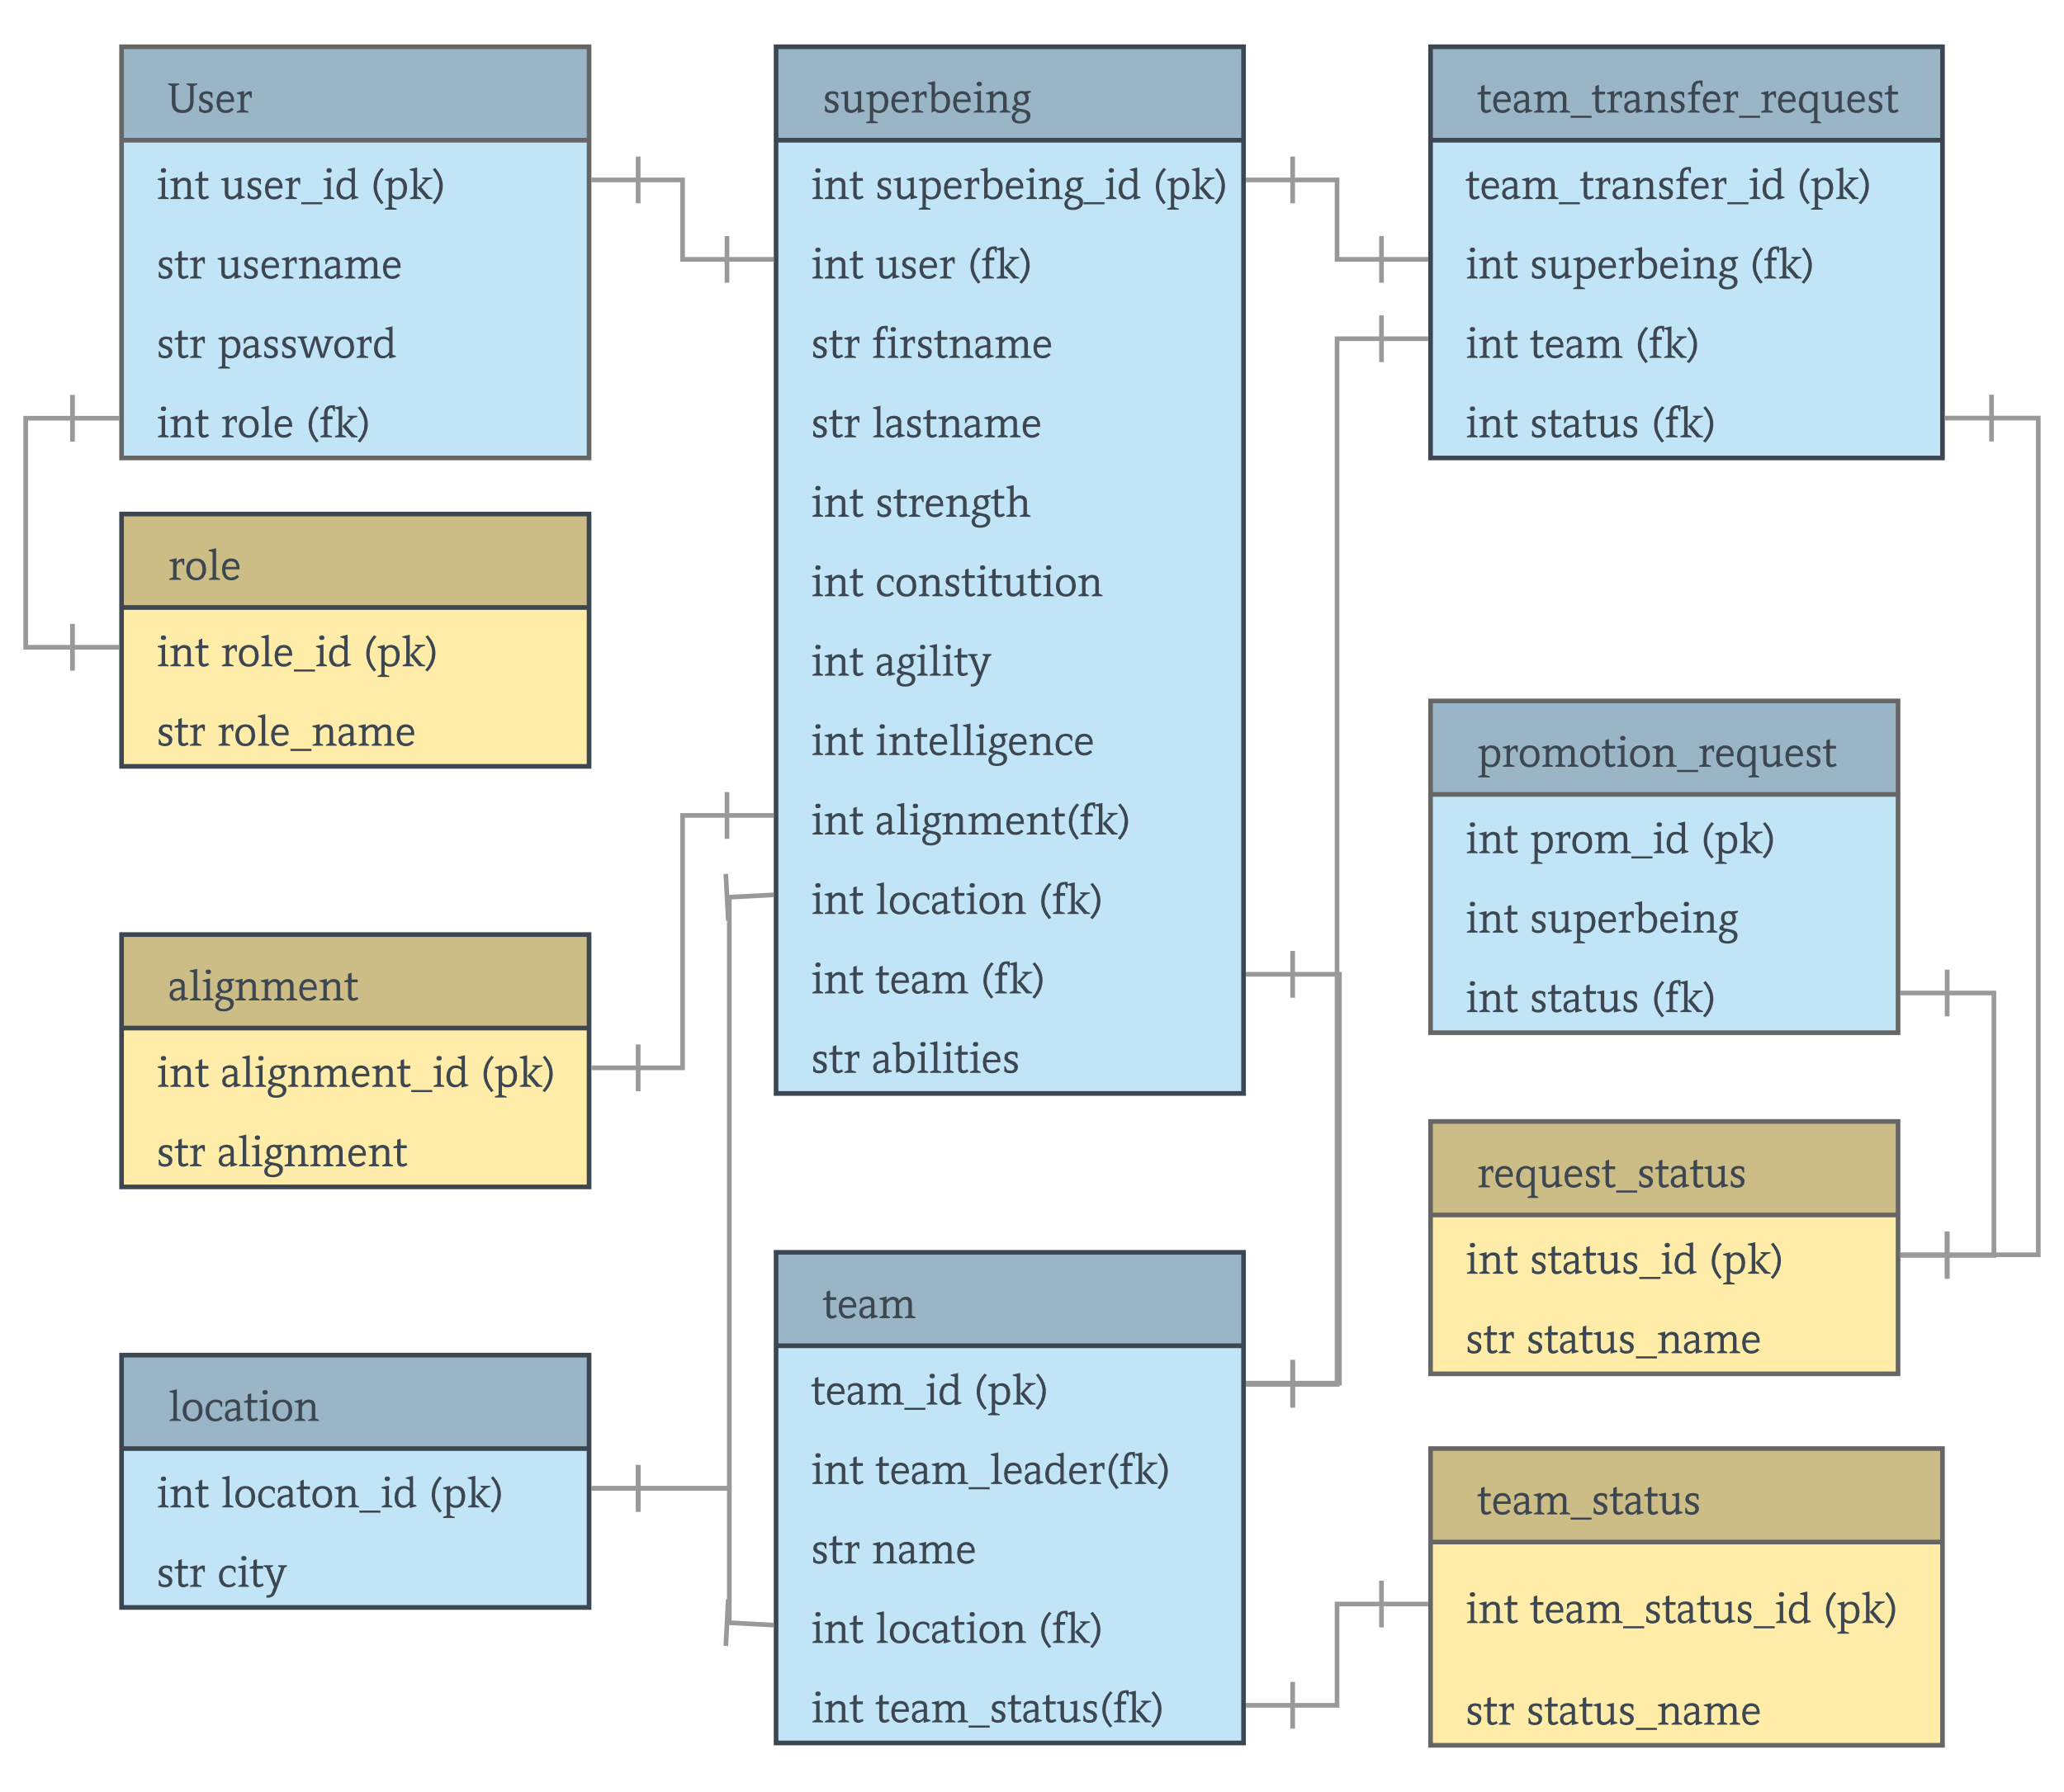

Power Scale:

|  |  |  |
| --- | --- | --- |
| # | Meaning | Example |
| 0 | Dead | Amy Winehouse |
| 5 | Pansy Human | Steve Rogers |
| 10 | Normal Human | Average Joe |
| 20 | Maximum Achievable Strength | John Cena |
| 30 | Superhuman | Captain America |
| 40 | Extreme Superhuman | SPARTAN-II (Mjolnir) |
| 50 | Demigod | Thor, Hulk (MCU) |
| 100 | Astronomical (Soft Max) | One-Punch Man |
| 1000 | Universal | Heaven Piercing Gurren Lagann |